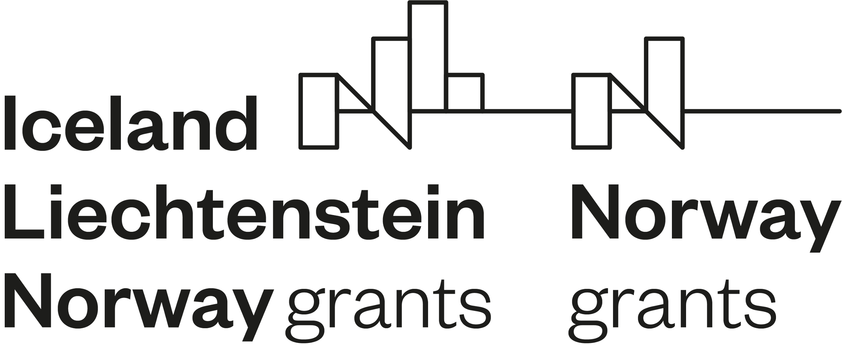

The socio-economic impact of the project

Project information
Project number
Project title
Project Promoter
Project partners

The wider socio-economic implications of the project
Please describe the actual or future socio-economic impact of the project on:

- gender equality, action taken during the project implementation to provide gender balance and other actions which promote gender equality:
required to fill in
maximum 1000 characters

- ethical issues:
required to fill in
maximum 1000 characters

- efforts to involve other actors and to spread awareness:
required to fill in
maximum 1000 characters

- the plan for the use and dissemination of foreground knowledge (knowledge produced within the project) and intellectual property:
required to fill in
maximum 1000 characters

